

**Final Year Project Report**

**Title: Smart Automated Classroom Attendance System Using Face Recognition**

**Submitted by**

Muhammad Ahmed (13460) (Team Leader)

Faiq Ali Siddiqui (14020)

Syeda Aliza Ali (13550)

Maryam Rehan (13541)

**Instructor**

**Dr. Aarij Mahmood Hussaan**

**Supervisor**

**Dr. Affan Alim**

**Project Description**

**Abstract**:

The project aims to develop an automated attendance system for classrooms using camera equipped with facial recognition technology. Traditional attendance tracking methods often suffer from inefficiencies, such as manual recording errors and time-consuming processes. By leveraging cameras and advanced facial recognition algorithms, this system offers a more accurate, efficient, and convenient way to monitor student attendance in educational settings. The system logs attendance in real-time, provides notifications of anomalies.

1. **Introduction**:

In today's fast-paced educational environment, efficient management of classroom attendance poses a significant challenge for educators and administrators alike. Traditional methods of attendance taking, such as manual roll calls or paper-based sign-in sheets, are time-consuming, prone to errors, and often lack real-time insights into student attendance patterns. To address these challenges and streamline the attendance tracking process, we propose the "Smart Automated Classroom Attendance System."

The Smart Automated Classroom Attendance System (SACAS) leverages cutting-edge technology, including Machine learning/Deep learning, based on biometric recognition and computer vision, to revolutionize the way attendance is managed in educational institutions. By harnessing the power of advanced algorithms and sensor technology, the system offers a seamless and efficient solution for tracking student attendance in real-time. Essentially, a database will be integrated to the system for recording the attendance and other in out of the activities of students. The flow diagram of the complete proposed system is shown in Figure -1.

Essentially, the system comprises six primary implementation modules: (i) Creation of the database using registration, (ii) Developing the Machine learning model using available class database, (iii) Detection and recognition of the faces, (iv) Design of the database for attendance records, (v) Integration of the camera, and (vi) User interface development for image registration. Ultimately, each module within the proposed models will be harmoniously integrated to function as a cohesive product. The experiment will be tested on two different senior of dataset (i) already available face dataset like FERET, or Georgia tech, and other is our classroom student’s dataset. **You Only Look Once (YOLO)**: YOLO is another fast and accurate object detection algorithm. It divides the input image into a grid and predicts bounding boxes and class probabilities directly from the grid cells, resulting in real-time performance. **ResNet**: Residual Networks (ResNet) are a family of CNN architectures featuring residual connections, which allow for the training of very deep networks. ResNet variants are commonly used for face detection and recognition tasks due to their excellent performance and scalability. Therefore, both deep learning techniques will be used in our proposed framework of SACAS. The attendance record will be maintained in MySQL database. A smart attendance database will be designed in MySQL where the attendance activity will be maintained.

**Objectives:**

* Develop a system that integrates in classrooms attendance.
* To automate the attendance marking processes using state-of-the-art technology such as machine learning and deep learning face recognition.
* To ensure high accuracy in face recognition, capable of working in various lighting and environmental conditions.
* To create a scalable and secure system that can handle the addition of new users (i.e., faces) and safeguard personal data. Registration process.
* Automatically log attendance data in real-time and store it securely.
* Provide administrators with access to attendance records, real-time monitoring, and analytics.
* Ensure compliance with data privacy regulations and security standards.

**Technical Specifications:**

* **Machine Learning Libraries:**

Utilize the Scikit Learn, TensorFlow, and Keras for building and training the face recognition model. OpenCV will be used for image processing tasks.

* **Model Choice**:

Consider using convolutional neural networks (CNNs) for face recognition. Pre-trained models such as VGGFace,FaceNet, or DeepFace can be fine-tuned on a specific dataset to improve accuracy.

* **Programming Language:**

Python, due to its comprehensive support for data science and machine learning libraries.

* **Database Management:**

A relational database like MySQL or PostgreSQL for storing attendance records; MongoDB can be an alternative for more flexible data storage.

* **Deployment Platform:**

Web application (using frameworks like Flask or Django).

**Development Steps:**

* **Dataset Collection and Preparation:**

Collect a dataset of face images for all individuals. This dataset must be large and varied enough to train a robust model. Preprocess the images (resize, normalize, etc.) to make them suitable for training.

* **Model Training:**

Select a suitable machine learning model for face recognition. You could start with a pre-trained model and fine-tune it on your specific dataset to improve its accuracy. This process involves training the model to recognize the distinct features of each individual’s face.

* **System Integration:**

Integrate the trained model into an application that captures images from a video feed, uses the model to recognize faces, and marks attendance by logging the date, time, and person's identity into a database.

* **User Interface Development:**

Develop a user-friendly interface for both administrators and users. For administrators, provide functionalities to add or remove individuals from the system, generate attendance reports, and manage the database. For users, ensure the interface is simple and requires minimal interaction.

* **Testing and Evaluation:**

Rigorously test the system to evaluate its accuracy and performance in real-world conditions. This may involve testing with different lighting conditions, angles, and facial expressions to ensure the model's robustness.

**Challenges:**

* **Accuracy in Varied Conditions:**

Ensuring the model accurately recognizes faces under different lighting conditions, angles, and facial expressions.

* **Scalability**:

Designing the system to easily accommodate new users and handle large databases efficiently**.**

* **Privacy and Security**:

Implementing strong data protection measures to safeguard personal information.

**Functional Requirements:**

* **Camera Integration:**

The system shall integrate with cameras installed in the classroom to capture real-time footage of the students present in the class.

* **Face Recognition:**

The system shall employ facial recognition algorithms to accurately identify students who is present in the classroom.

* **Attendance Logging:**

The system shall automatically log the attendance of each student based on their presence in the classroom captured by cameras.

* **Multiple Camera Support:**

The system shall support multiple cameras if the classroom is equipped with more than one camera for comprehensive coverage for the students to capture their faces using machine learning and deep learning approach.

* **User Interface:**

The system shall have a user-friendly interface for teachers/administrators to view attendance records, monitor real-time attendance, and manage the system.

* **Notification System:**

The system shall integrate a notification system to alert teachers/administrators of any anomalies or discrepancies in attendance records.

* **Integration with Existing Systems**:

The system shall provide the ability to integrate with existing student information systems or databases for seamless attendance management from the university database of the students record.

* **Time Threshold for Attendance:**

The system should define a time threshold to determine if a student who enters the classroom is considered present. For instance, if a student enters the classroom but leaves shortly after without attending most of the class, the system should not mark them as present.

* **Multiple Attendance Marking Methods:**

The system can incorporate alternative attendance marking methods in case the facial recognition system malfunctions or encounters technical difficulties. This could include options like students entering a PIN or scanning a QR code with their phones.

* **Guest Management:**

The system should have a mechanism to account for guests or visitors in the classroom who are not enrolled in the course.

* **Data Export:**

The system should allow for the export of attendance data in various formats (e.g., CSV, Excel) for further analysis or record-keeping.

**Non-Functional Requirements:**

* **Accuracy**:

The facial recognition algorithm shall achieve a minimum accuracy rate of 85%-90% in identifying students present in the classroom.

* **Maintainability:**

The system shall be designed in a modular fashion to facilitate easy updates and maintenance.

* **Interoperability**:

The system should be capable of exporting data in any format (e.g., CSV, Excel) to ensure compatibility with various data analysis tools.

* **Cost-effectiveness**:

The system should be developed and implemented in a cost-effective manner, considering factors like hardware, software, and maintenance requirements.

* **Auditability**:

The system shall maintain detailed logs of attendance records, including timestamps of when students were recognized and logged.

* **Data Integrity**:

The system shall ensure that all attendance data is accurately captured, stored, and retrieved without any corruption or loss.

* **User Support**:

The system shall provide comprehensive user support, including help documentation, tutorials, and a dedicated support channel for teachers and administrators to resolve issues quickly.

* **Response Time:**:

The system's response time for facial recognition and attendance logging shall be optimized to ensure minimal delay, especially during peak usage hours.

**Business Flow Diagram:**

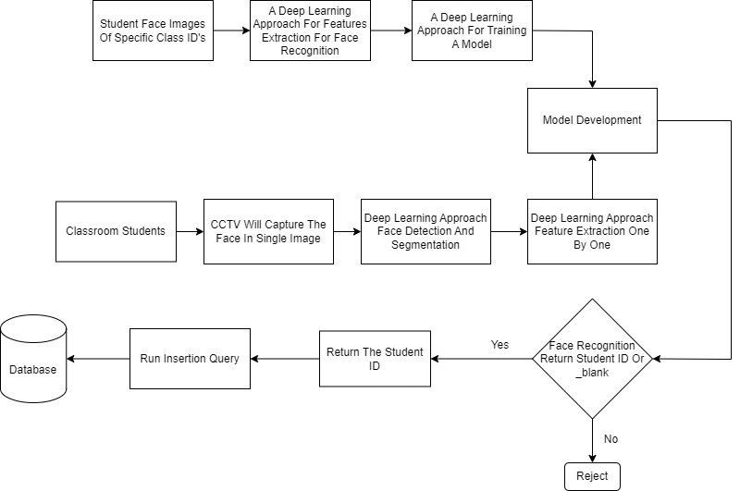

Figure 1: A Complete Flow Diagram Of Proposed Model